**­­­**

Class 7

**Lecture 24**

**Introduction to**

**MS Access.**

**MS Access**



**Lab Objectives:**

* Introduction to MS Access.
* Overview and uses of MS Access.

**MS Access**

Microsoft Access is a Database Management System (DBMS) from Microsoft that combines the relational Microsoft Jet Database Engine with a graphical user interface and software development tools

It is a Relational Database Management System (RDBMS), designed primarily for home or small business use. Microsoft Access (or MS Access) is bundled as part of the Microsoft Office suite. It is only available on the PC version.

Access has traditionally been known as a desktop database system because its functions are intended to be run from a single computer (as opposed to a client/server system where the database application is installed on a server, then accessed from multiple client machines) across a network.

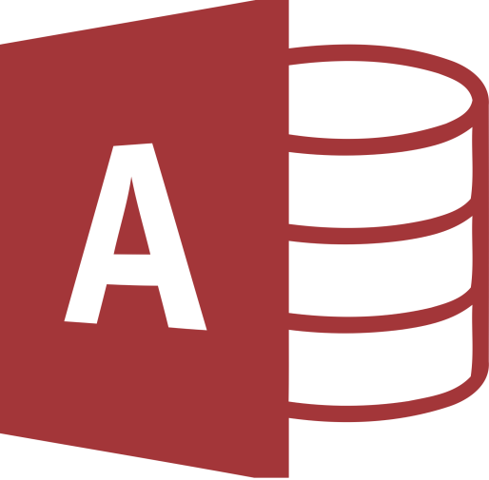

**About MS Access**

* Microsoft Access is just one part of Microsoft’s overall data management product strategy.
* It stores data in its own format based on the Access Jet Database Engine.
* It can also import or link directly to data stored in other applications and databases.
* Access can also understand and use a wide variety of other data formats, including many other database file structures.
* You can export data to and import data from word processing files, spreadsheets, or database files directly.
* Access can work with most popular databases that support the Open Database Connectivity (ODBC) standard, including SQL Server, Oracle, and DB2.
* Software developers can use Microsoft Access to develop application software.

**Access versus Excel**

Microsoft Access stores various types of data in a way that is easy to retrieve. It includes various features in order to achieve this.

Excel, on the other hand, leans more towards numerical data and performing calculations on that data.

While you can certainly store various types of data in an Excel spreadsheet (or any other spreadsheet for that matter).

A specialized database application like Access includes specific features for declaring and maintaining various types of data. Access allows you to restrict the data that users enter into each field. It also allows you to link related data across multiple tables. And it also provides other useful features such as forms, reports, query builder, and more.

**Version**

MS Access 2016

MS Access 2013

MS Access 2003

Microsoft Access stores information which is called a database. To use MS Access, you will need to follow these four steps-

**Database Creation**

Create your Microsoft Access database and specify what kind of data you will be storing.



**Data Input**

After your database is created, the data of every business day can be entered into the Access database.

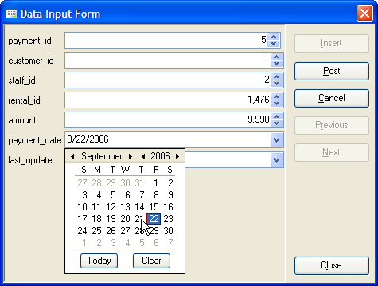

**Query**

This is a fancy term to basically describe the process of retrieving information from the database.



**Report**

Information from the database is organized in a nice presentation that can be printed in an Access Report.

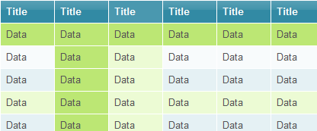

**MS Access Interface**

